React – Introduction
Importing React and ReactDOM modules
We can import React and ReactDOM modules as below:
import React from "react";
import ReactDOM from "react-DOM";

This allows us to use the functions in this module to, for example, use HTML embedded in JS or render our code (i.e. show it in the screen). For example, with these modules, we can render elements in a much simpler way:

With React and ReactDOM:

ReactDOM.render(<h1>Hello World</h1>>, document.getElementById("root"));

Without React and ReactDOM:

var h1 = document.createElement("h1");
h1.innerHTML = "Hello World";
document.getElementById("root.appendChild")(h1)

The root is simply a div in out HTML code where all our JS code goes:

HTML Code:

<!DOCTYPE html>
<html lang="en">
<head>
<title>Document</title>
<link rel="stylesheet" href="styles.css" />
</head>

<body>
<div id="root"></div>
<script src="../src/index.js" type="text/jsx"></script>
</body>
</html>

Note: React allows us to use ES6 without worrying with the browser. Inside the React module there is something called Babel which is a JS compiler. So, it is able to get next generation JS like ES6,7 or 8 and compile it down to a version of JS every browser can understand (even Internet Explorer).

Rendering can only take one HTML parent element, but we if put everything inside a div, whatever is inside that div doesn’t count. For example, we could render:

ReactDOM.render(
<div>
<h1>Hello</h1>
<h1>World</h1>
</div>
, document.getElementById("root"));

But we couldn’t render:

ReactDOM.render(
<h1>Hello</h1>
<h1>World</h1>
, document.getElementById("root"));

This syntax that allows us to use React and put HTML embedded in JS code is called JSX.

Camel Case Syntax

While in HTML we are used to write classes in lower case, in JSX we use camel notation:

HTML | JSX
<div tabindex="1">  <button onclick="myFunction()">click me</button>  <label for='name'>Name</label>  <input readonly id='name' />  </div> | return (  <div tabIndex={1}>  <button onClick={myFunction}>click me</button>  <label htmlFor='name'>Name</label>  <input readOnly={true} id='name' />  </div>  )

Class Keyword

The class keyword is not used in JSX. Instead, use className.

Self-closing tags in JSX

HTML5 allowed us the not use / on self-closing tags. However, in JSX that is still needed:
HTML | JSX
return <img>; | return <img />;

JS Expressions in JSX

JSX stands for JavaScript XML. It is simply a syntax extension of JavaScript. It allows us to directly write HTML in React (within JavaScript code). In JSX, only one single parent element can be returned.

You can write JS expressions inside HTML using {}. For example:

import React from "react";
import ReactDOM from "react-dom";

const name = "Angela"
const num = 7

ReactDOM.render(
<div>
<h1>My name is {name}</h1>
<h2>You luck number is {num}</h2>
<h2>You luck number is {3 + 4}</h2>
<h2>You luck number is {Math.ceil(Math.random()*10)}</h2>
</div>
, document.getElementById("root"));

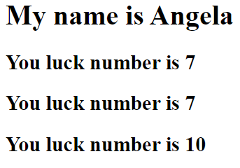
JSX Attributes & Styling React Elements

In order to keep the styling in the CSS, we should use JSX to give classes to the elements, and not to style them. See the example below, where we use className to assign a class to the elements (and then the classes are styles in the CSS file).

The code below is simply a list of 3 items (images) with a heading, and styles applied to the different elements

JSX file:

import React from "react";
import ReactDOM from "react-dom";

ReactDOM.render(
<div>
<h1 className="heading">My Favourite Foods</h1>
<img
className="food-img"
alt="bacon"
src="https://hips.hearstapps.com/hmg-prod.s3.amazonaws.com/images/delish-190621-air-fryer-bacon-0035-landscape-pf-1567632709.jpg?crop=0.645xw:0.967xh;0.170xw,0.0204xh&resize=480:*"
/>
<img
className="food-img"
alt="jamon"
src="https://images-na.ssl-images-amazon.com/images/I/71lNrnbMXsL._SL1200_.jpg"
/>
<img
className="food-img"
alt="noodles"
src="https://www.errenskitchen.com/wp-content/uploads/2014/04/quick-and-easy-chinese-noodle-soup3-1.jpg"
/>
</div>,
document.getElementById("root")
);

CSS:

.heading {
color: red;
}

.food-img {
height: 100px;
width: 100px;
}

Result:



Inline Styling for React Elements

As mentioned, styling should always be in the CSS file, and we should use JSX to give classes to the elements only. But there are some exceptions.

You may want to style to update on the fly, i.e. overwrite the normal style for a certain element. That’s when inline styling becomes useful.

import React from "react";  import ReactDOM from "react-dom";  const customStyle = {  color: "red",  fontSize: "20px"  };  ReactDOM.render(  <div>  <h1 style={customStyle}>Hello World</h1>  </div>,  document.getElementById("root")  ); | 

You can also change a single property of the object. This this case, the final color is blue because the code was called after. This is useful, for example, if we want to change the style when a button is clicked (for example). In that case, we would add an event listener to the h1 element and change the property within a function (more on event listeners later).

import React from "react";  import ReactDOM from "react-dom";  const customStyle = {  color: "red",  fontSize: "20px"  };  customStyle.color = "blue";  ReactDOM.render(  <div>  <h1 style={customStyle}>Hello World</h1>  </div>,  document.getElementById("root")  ); | 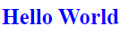
React Components

Components allow us to split up a large file or a complex web structure into smaller components.

We also get the added benefit of reusing each of these components when we need the same functionality.

All components have names which start with a capital letter (Pascal case). That’s how React differentiates the HTML elements from the components.

It’s a good practice to keep the components in a separate folder, with a JSX extension (e.g. Heading.jsx).

To create components:

- Take the HTML elements you want to set as a component and put inside a separate JSX file. This HTML code will be returned inside a function, and that function exported in the end.
- Import the function in the parent file (in this case Index.js).
- Add the components inside the div (same name as the component function name).

Index.js | List.jsx
import React from "react";  import ReactDOM from "react-dom";  import Heading from "./components/Heading"  import List from "./components/List"  ReactDOM.render(  <div>  <Heading />  <List/>  <List />  </div>,  document.getElementById("root")  ); | import React from "react"  function List () {  return(  <ul>  <li>Bacon</li>  <li>Jamon</li>  <li>Noodles</li>  </ul>  )  }  export default List;
Heading.jsx | Result
import React from "react"  function Heading () {  return(  <h1>My Favourite Food</h1>  )  }  export default Heading | 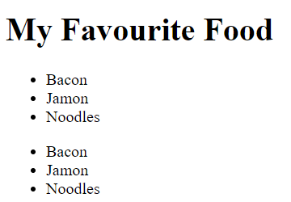
As you can see, because we have called the component twice in the component tree (see index.js), the component List was easily repeated by rendering it twice.

Normally, there are no HTML elements in the index.js of React apps. There is just one custom component called App.jsx.

So, basically, the Index.js file will always look very simple, like it is below.

Index.js | List.jsx
import React from "react";  import ReactDOM from "react-dom";  import App from "./components/App"  ReactDOM.render(<App/>,document.getElementById("root")); | import React from "react"  function List () {  return(  <ul>  <li>Bacon</li>  <li>Jamon</li>  <li>Noodles</li>  </ul>  )  }  export default List;
Heading.jsx | App.jsx
import React from "react"  function Heading () {  return(  <h1>My Favourite Food</h1>  )  }  export default Heading | import React from "react";  import Heading from "./Heading"  import List from "./List"  function App () {  return(  <div>  <Heading/>  <List/>  <List/>  </div>  );  }  export default App;

ES6 Import/Export Modules

Have a look at the example below.

Index.js | Math.jsx
import React from "react";  import ReactDOM from "react-dom";  import pi, {doublePi,triplePi} from "./components/Math"  ReactDOM.render(  <ul>  <li>{pi}</li>  <li>{doublePi()}</li>  <li>{triplePi()}</li>  </ul>  ,document.getElementById("root")); | const pi = 3.14;  function doublePi() {  return pi * 2;  }  function triplePi() {  return pi * 3;  }  export default pi;  export {doublePi, triplePi};
Result
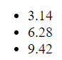

Here we export more than one element from a component.

When this happens, one of the elements is exported as default. All the other ones are exported and imported inside {}.

Importing Local Images

When importing local images, you can following the setup below:

import img1 from "./images/book-1.jpg";
import img2 from "./images/book-2.jpg";
import img3 from "./images/book-3.jpg";

export const books = [
{
author: "Jordan Moore",
title: "Interesting Facts For Curious Minds",
img: img1,
id: 1,
},
{
author: "James Clear",
title: "Atomic Habits",
img: img2,
id: 2,
},
{
author: "Stephen King",
title: "Fairy Tale",
img: img3,
id: 3,
},
];

React Props

Props stands for properties. Props are arguments passed into React components when they are created or setup. Then they are defined when the component is rendered.

If the property value sent is not a string, this need to be inside curly braces {}.

We can assign different values to the properties each time we call a component, as it is shown in the image below. This is useful when we want to reuse a block that has the same structure, but different data.

Index.js | Card.jsx
import React from "react";  import ReactDOM from "react-dom";  import App from "./components/App"  ReactDOM.render(  <div>  <h1>My Contacts</h1>  <App/>  </div>,  document.getElementById("root")  ); | import React from "react";  function Card(props) {  return (  <div>  <h2>{props.name}</h2>  <p>{props.tel}</p>  <p>{props.email}</p>  </div>  );  }  export default Card;
App.jsx | Result
import React from "react"  import Card from "./Card"  function App () {  return(  <div>  <Card  name="Beyonce"  tel="+123 456 789"  email="b@beyonce.com"  />  <Card  name="Jack Bauer"  tel="+7387384587"  email="jack@nowhere.com"  />  </div>  )  }  export default App; | 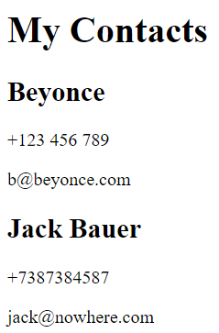
A more organized way to give properties to a component is by creating a separate JS file with an array of objects, and then access the properties of each object it using the index number and the name of the property.

We can also use destructuring when setting up the object, so instead of repeating props each time we want to access it, we destruct it once (see Card file).

Index.js | Card.jsx
import React from "react";  import ReactDOM from "react-dom";  import App from "./components/App"  ReactDOM.render(  <div>  <h1>My Contacts</h1>  <App/>  </div>,  document.getElementById("root")  ); | import React from "react";  function Card(props) {  const {name, tel, email} = props;  return (  <div>  <h2>{props.name}</h2>  <p>{props.tel}</p>  <p>{props.email}</p>  </div>  );  }  export default Card;
App.jsx | Contact.js
import React from "react"  import Card from "./Card"  import contacts from "../Contacts"  function App () {  return(  <div>  <Card  name={contacts[0].contactName}  tel={contacts[0].contactTel}  email={contacts[0].contactEmail}  />  <Card  name={contacts[1].contactName}  tel={contacts[1].contactTel}  email={contacts[1].contactEmail}  />  </div>  )  }  export default App; | const contacts = [  {  contactName: "Beyonce",  contactTel: "+123 456 789",  contactEmail: "b@beyonce.com"  },  {  contactName: "Jack Bauer",  contactTel: "+7387384587",  contactEmail: "jack@nowhere.com"  }  ]  export default contacts;
We could also destructure directly in the Card component arguments:

Card.jsx
import React from "react";

function Card({name, tel, email}) {
return (
<div>
<h2>{props.name}</h2>
<p>{props.tel}</p>
<p>{props.email}</p>
</div>
);
}

export default Card;

Children Prop

If we want to render something that is between the component tags, we need to use a special prop – and the name is children.
Index.js | Book.jsx
import React from "react";  import ReactDOM from "react-dom";  import App from "./components/App"  ReactDOM.render(  <div>  <App/>  </div>,  document.getElementById("root")  ); | import React from "react";  function Book ({img, title, author, children}) {  return (  <article className="book">  <img src={img} alt={title} />  <h2>{title}</h2>  <h4>{author}</h4>  {children}  </article>  );  };  export default Book;
App.jsx | Booklist.js
import React from "react"  import Book from "./Book"  import books from "../Booklist"  function App () {  return(  <div>  <Book  img={books[0].img}  title={books[0].title}  author={books[0].author}  <p>This is extra text</p>  <button>click me</button>  />  </Book>  <Book  img={books[1].img}  title={books[1].title}  author={books[1].author}  />  </div>  )  }  export default App; | const books = [  {  author: "Lloyd Devereux Richards",  title: "Stone Maidens",  img: "https://images-na.ssl-images-amazon.com/images/I/51NcOGy0y3L._AC_UL600_SR600,400_.jpg",  },  {  author: "B. Dylan Hollis",  title: "Baking Yesteryear: The Best Recipes from the 1900s to the 1980s",  img: "https://images-na.ssl-images-amazon.com/images/I/81Oa54UCQoL._AC_UL600_SR600,400_.jpg",  }  ]  export default contacts;

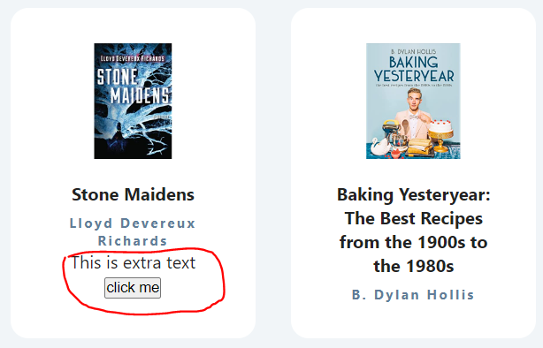

Mapping Data to Components

map() creates a new array from calling a function for every array element. For example:

const numbers = [65, 44, 12, 4];
const newArr = numbers.map(myFunction)

function myFunction(num) {
return num * 10;
}
console.log(newArr)
//expected output [650, 440, 120, 40]

Have a look at the example below. The map() function loops through the array of contacts and calls the function createCard() on every item of the array.

So, on the first loop, it gets hold of the properties of each object in the contacts array (contactName, contactTel and contactEmail). Then, when we call the component, we assign those values we took and assign it to the Props values (name, tel and email) of the first object (Beyonce).

The key prop is mandatory when mapping through arrays. Each object of that array should have a key property associated with a unique id.

Index.js | Card.jsx
import React from "react";  import ReactDOM from "react-dom";  import App from "./components/App"  ReactDOM.render(  <div>  <h1>My Contacts</h1>  <App/>  </div>,  document.getElementById("root")  ); | import React from "react";  function Card(props) {  return (  <div>  <h2>{props.name}</h2>  <p>{props.tel}</p>  <p>{props.email}</p>  </div>  );  }  export default Card;
App.jsx | Contact.js
import React from "react"  import Card from "./Card"  import contacts from "../Contacts"  function createCard(contact) {  return (  <Card  key={contact.id}  name={contact.contactName}  tel={contact.contactTel}  email={contact.contactEmail}  />  );  }  function App () {  return(  <div>  {contacts.map(createCard)}  </div>  )  }  export default App;  } | const contacts = [  {  id = 1,  contactName: "Beyonce",  contactTel: "+123 456 789",  contactEmail: "b@beyonce.com"  },  {  id = 2,  contactName: "Jack Bauer",  contactTel: "+7387384587",  contactEmail: "jack@nowhere.com"  }  ]  export default contacts;
Result
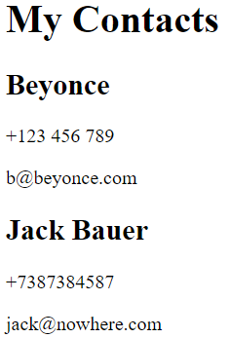

Another way is by using the spread operator.

Index.js | Book.jsx
import React from "react";  import ReactDOM from "react-dom";  import App from "./components/App"  ReactDOM.render(  <div>  <App/>  </div>,  document.getElementById("root")  ); | import React from "react";  function Book ({img, title, author, children}) {  return (  <article className="book">  <img src={img} alt={title} />  <h2>{title}</h2>  <h4>{author}</h4>  {children}  </article>  );  };  export default Book;
App.jsx | Booklist.js
import React from "react"  import Book from "./Book"  import books from "../Booklist"  function App () {  return (  <section className="booklist">  {books.map((book) => {  return <Book {...book} key={book.id} />;  })}  </section>  );  }  export default App; | const books = [  {  author: "Lloyd Devereux Richards",  title: "Stone Maidens",  img: "https://images-na.ssl-images-amazon.com/images/I/51NcOGy0y3L._AC_UL600_SR600,400_.jpg",  },  {  author: "B. Dylan Hollis",  title: "Baking Yesteryear: The Best Recipes from the 1900s to the 1980s",  img: "https://images-na.ssl-images-amazon.com/images/I/81Oa54UCQoL._AC_UL600_SR600,400_.jpg",  }  ]  export default contacts;

Conditional Rendering

Sometimes we may want to show a different component depending on some condition – and that’s when we use conditional rendering.

In the example below, it will show “Hello” if the user is Logged in, or the Login screen if the user hasn’t logged in yet. For this we use the Ternary Operator, which follow the syntax below:

Condition ? Do it if True : Do it if False

So, when we call the following line:

{isLoggedIn === true ? <h1>Hello</h1> : <Login />}

It means that, depending on the value of the isLoggedIn variable (true or false), we will display different things. If it is true, it will display “Hello”. If it is false, it will display the Login component.

Note: In this case, for simplification, we are just changing the value of isLoggedIn manually.

Index.js | App.jsx
import React from "react";  import ReactDOM from "react-dom";  import App from "./components/App";  ReactDOM.render(<App />, document.getElementById("root")); | import React from "react";  import Login from "./Login";  var isLoggedIn = false;  function App() {  return (  <div className="container">  {isLoggedIn === true ? <h1>Hello</h1> : <Login />}  </div>  );  }  export default App;
Input.jsx | Login.js
import React from "react";  function Input(props) {  return <input type={props.type} placeholder={props.placeholder} />;  }  export default Input; | import React from "react";  import Input from "./Input";  function Login(props) {  return (  <form className="form">  <Input type="text" placeholder="Username" />  <Input type="password" placeholder="Password" />  <button type="submit">Login</button>  </form>  );  }  export default Login;
Result

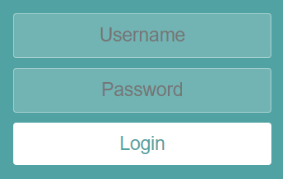 |  | var isLoggedIn = false;
 |  | var isLoggedIn = true;

Now imagine we want to add a “confirm password” field in case the user was not registered:

Index.js | App.jsx
import React from "react";  import ReactDOM from "react-dom";  import App from "./components/App";  ReactDOM.render(<App />, document.getElementById("root")); | import React from "react";  import Form from "./Form";  var userIsRegistered = false;  function App() {  return (  <div className="container">  <Form isRegistered={userIsRegistered} />  </div>  );  }  export default App;
Input.jsx
import React from "react";

function Input(props) {
return <input type={props.type} placeholder={props.placeholder} />;
}

export default Input;

Form.jsx
import React from "react";
import Input from "./Input";

function Form(props) {
return (
<form className="form">
<Input type="text" placeholder="Username" />
<Input type="password" placeholder="Password" />
{props.isRegistered === false && (
<Input type="password" placeholder="Confirm Password" />
)}
<button type="submit">
{props.isRegistered === true ? "Login" : "Register"}
</button>
</form>
);
}

export default Form;
Result
 |  | var isRegistered = true;
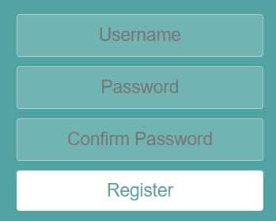 |  | var isLoggedIn = false;

In this case, we want to show the field “confirm password” if the user is not registered. Thus, we have to had the component inside a condition statement (ternary operator).

Also, there are different ways having a condition where it either shows or doesn’t show something.

isRegistered === false && (<Input type="password" placeholder="Confirm Password" />)
isRegistered === false ? (<Input type="password" placeholder="Confirm Password" />) : null
!isRegistered ? (<Input type="password" placeholder="Confirm Password" />) : null

React Hooks – Use State

Hooks allow function components to have access to state and other React features.
The state is a built-in React object that is used to contain data or information about the component. A component’s state can change over time; whenever it changes, the component re-renders. The change in state can happen as a response to user action or system-generated events and these changes determine the behavior of the component and how it will render.
The React useState Hook allows us to track state in a function component.
useState accepts an initial state and returns two values:
- The current state.
- A function that updates the state.
For example, the code below takes the variable color as the current value, and setColor as the function that updates de color. Lastly, we set the initial state to an empty string: useState("")

function FavoriteColor() {
const [color, setColor] = useState("");
}

The useState Hook can be used to keep track of strings, numbers, booleans, arrays, objects, and any combination of these.
For example, below it is tracking the state of 3 variables brand, model and year.
function Car() {
const [brand, setBrand] = useState("Ford");
const [model, setModel] = useState("Mustang");
const [year, setYear] = useState("1964");

return (
<>
<h1>My {brand}</h1>
<p>
It is a {model} from {year}.
</p>
</>
)
}

Or, we can just use one state and include an object instead.

function Car() {
const [car, setCar] = useState({
brand: "Ford",
model: "Mustang",
year: "1964",
});

return (
<>
<h1>My {car.brand}</h1>
<p>
It is a {car.model} from {car.year}.
</p>
</>
)
}

Both would result in:
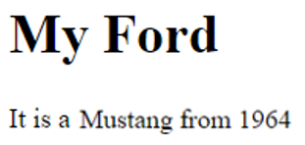
Consider the following code, where we have a counter that goes up every time the button + is pressed.
import React from "react";  import ReactDOM from "react-dom";  var count = 0;  function increase() {  count++  }  ReactDOM.render(  <div className="container">  <h1>{count}</h1>  <button onClick={increase}>+</button>  </div>  ) | 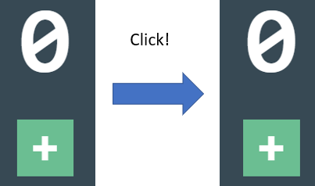  The variable count increases in value. However, it is not re-rendered to the screen.
var count = 0;  function increase() {  count++  ReactDOM.render(  <div className="container">  <h1>{count}</h1>  <button onClick={increase}>+</button>  </div>  )  }  ReactDOM.render(  <div className="container">  <h1>{count}</h1>  <button onClick={increase}>+</button>  </div>  ) | 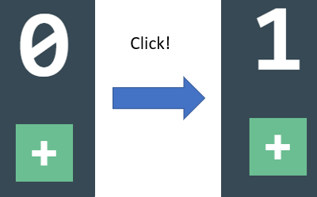  We can copy and paste bit of the code that renders the HTML elements inside the increase function so it is rendered every time the buttom is clicked, but that’s not good practice due to repetitive and long code.
import React, { useState } from "react";  function App() {  const [count, setCount] = React.useState(0);  function increase() {  setCount(count + 1);  }  return (  <div className="container">  <h1>{count}</h1>  <button onClick={increase}>+</button>  </div>  );  }  export default App; |   The correct way is to use React.useState().  It takes the initial value as the argument (in this case 0).  It has 2 variables associated:  - The value that is going to change (count)  - A function to change that value (setCount)  The setCount function will be inside another function, which is going to be called when the event is triggered. This is the typical format when using React Hook.

Event Handling in React

A lot of the times, we will want events to change the state of React components. Imagine you have the following interface and you want to:
- Change the text from “Hello” to “Submitted” as soon as you submit a name.
- Change the background color of the button if you are hovering the mouse over it.

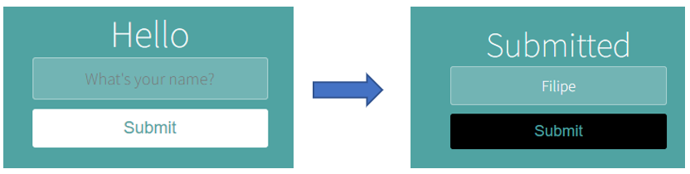

We will want to control the state of two components:
- Heading Text
- If the Mouse is over the “submit” button

So we need to create 2 hooks:

const [headingText, setHeadingText] = React.useState("Hello");
const [isMousedOver, setMouseOver] = React.useState(false);

To change the state of the heading when the button “submit” is clicked, we need to create a function (and call it with an event in the button element, as you will see later).

function handleClick() {
setHeadingText("Submitted");
}

And we need two functions (one to change isMousedOver to true and other to change it to “false”)

function handleMouseOver() {
setMouseOver(true);
}

function handleMouseOut() {
setMouseOver(false);
}

We need to assign conditional rendering to the background color of the button, depending on the state of isMousedOver.
style={{ backgroundColor: isMousedOver ? "black" : "white" }}

Finally, we need to assign event handlers to the button element to call the functions when they are triggered:

<button
style={{ backgroundColor: isMousedOver ? "black" : "white" }}
onClick={handleClick}
onMouseOver={handleMouseOver}
onMouseOut={handleMouseOut}
>Submit
</button>

See the full code below:

import React from "react";

function App() {
const [headingText, setHeadingText] = React.useState("Hello");
const [isMousedOver, setMouseOver] = React.useState(false);

function handleClick() {
setHeadingText("Submitted");
}

function handleMouseOver() {
setMouseOver(true);
}

function handleMouseOut() {
setMouseOver(false);
}

return (
<div className="container">
<h1>{headingText}</h1>
<input type="text" placeholder="What's your name?" />
<button
style={{ backgroundColor: isMousedOver ? "black" : "white" }}
onClick={handleClick}
onMouseOver={handleMouseOver}
onMouseOut={handleMouseOut}
>Submit
</button>
</div>
);
}
export default App;
Event Handler and useState Example

The code below renders a list with buttons. The remove button removes the individual name, while the clear items removes the whole array.
main.js | App.jsx
import React from 'react';  import ReactDOM from 'react-dom/client';  import './index.css';  import App from './App';  const root = ReactDOM.createRoot(document.getElementById('root'));  root.render(<App />); | import Starter from "./tutorial/01-useState/starter/03-useState-array.jsx";  function App() {  return (  <div className="container">  <Starter />  </div>  );  }  export default App;
data.js | Result
export const data = [  { id: 1, name: 'john' },  { id: 2, name: 'peter' },  { id: 3, name: 'susan' },  { id: 4, name: 'anna' },  ]; | 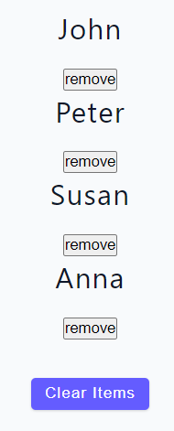
03-useState-array.jsx
import { data } from "../../../data";
import React from "react";

const UseStateArray = () => {
const [people, setPeople] = React.useState(data);

const removeItem = (id) => {
setPeople(people.filter((person) => person.id != id));
};

const clearAllItems = () => {
setPeople([]);
};

return (
<div>
{people.map((person) => {
const { id, name } = person;
return (
<div key={id}>
<h4>{name}</h4>
<button
type="button"
onClick={() => removeItem(id)}
>
remove
</button>
</div>
);
})}
<button
type="button"
style={{ marginTop: "2rem" }}
className="btn"
onClick={clearAllItems}
>
clear items
</button>
</div>
);
};

export default UseStateArray;

React Forms

Imagine we want to up add the submitted name to the heading like in the image below.

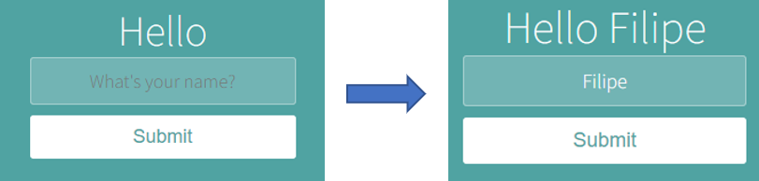

To do this, we need to:

Have 2 states: one to store and set the text input, and another one to store and set the heading text.

const [name, setName] = useState("");
const [headingText, setHeading] = useState("");

We need a function that is triggered each time the event onChange happens. This function will update the name input field value and store it in the name variable. In this case, event is pointing to the HTML element that triggered the event, in this case the input field. So, event.target.value will get the value of the input field.

function handleChange(event) {
setName(event.target.value);
}

When we click the submit button, we want it to delete the input field and send the it to the heading. When using forms and we have a submit button, the page refreshes, which means it will delete the name that was added to the heading. We can prevent this by using the line event.preventDefault().

function handleClick(event) {
setHeading(name);

event.preventDefault();

setName("");
}

So the final code looks like this:

import React, { useState } from "react";

function App() {
const [name, setName] = useState("");
const [headingText, setHeading] = useState("");

function handleChange(event) {
setName(event.target.value);
}

function handleClick(event) {
setHeading(name);

event.preventDefault();

setName("");
}

return (
<div className="container">
<h1>Hello {headingText}</h1>
<form onSubmit={handleClick}>
<input
onChange={handleChange}
type="text"
placeholder="What's your name?"
value={name}
/>
<button type="submit">Submit</button>
</form>
</div>
);
}

export default App;

Changing Complex State

Complex State is a way of managing the state of Javascript objects where you might have to retrieve the previous value of the object.

Imagine the example below, where we have 2 input fields: First Name and Last Name.

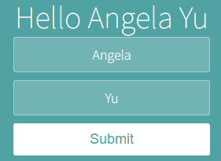

We want to add them to the message in the top “Hello” as we type. Without using complex state, and just the previous knowledge, it would look something like this:

import React from "react";

function App() {

const [fName, setFName] = React.useState("")
const [lName, setLName] = React.useState("")

function updateFName(e) {
setFName (e.target.value)
}

function updateLName(e) {
setLName (e.target.value)
}

return (
<div className="container">
<h1>Hello {fName} {lName}</h1>
<form>
<input onChange={updateFName} name="fName" placeholder="First Name" />
<input onChange={updateLName} name="lName" placeholder="Last Name" />
<button>Submit</button>
</form>
</div>
);
}
export default App;
Although it’s good practice, there are a few problems with this approach:
- There are so many functions.
- There are two separate constants.
- The inputs are not associated with each other.

So how can we improve this code?

- We can use useState but instead of storing a value, we can store an object fullName. This object is going to have 2 properties: fName and lName. So now, we are actually inserting {fullName.fName} and {fullName.lName} to the Hello title.

const [fullName, setFullName] = React.useState("{
fName: "" ,
lName: ""
})

- Instead of having two functions, we are going to have one functions that handle both names, starting by destructuring the fullName object, and hooking the two properties of it: value and name.

const {name, value} = e.target

Which means:
name = e.target.name (identifies which input field was changed)
value = e.target.value (identifies what the input field changed into)

- Now what we want to do is being able to update the full name, but without deleting the previous properties. We have to store them somehow.

In the setting function setFullName, we are going to pass an anonymous function as an argument, and that function is going to have prevValue as an argument. prevValue contains the previous value of the fullName object. So, if we console.log(prevValue) right at the start, what we get is:

Object (fName:"", lName:"")

By having access to the previous value, that means we can set the new value for a property, but keep the value of the other preperties as they are.

So, for example, if the First Name input field fname was changed, it will:

- call the function updateName
- update the value of the fName property with the value that was inserted in the input field that triggered the event (fName).
- The previous value of fullName properties is stored by the argument prevValue.
- So, the key that sets the value of the last name lName is set to prevValue.lName. That way, we keep its value.

function updateName(e) {
const { value, name } = e.target;

setFullName(prevValue => {
if (name === "fName") {
return {
fName: value,
lName: prevValue.lName
};
} else if (name === "lName") {
return {
fName: prevValue.fName,
lname: value
};
}
});
}

So, the final code looks like this:

import React, { useState } from "react";

function App() {
const [fullName, setFullName] = useState({
fName: "",
lName: ""
});

function updateName(e) {
const { value, name } = e.target;

setFullName(prevValue => {
if (name === "fName") {
return {
fName: value,
lName: prevValue.lName
};
} else if (name === "lName") {
return {
fName: prevValue.fName,
lname: value
};
}
});
}

return (
<div className="container">
<h1>
Hello {fullName.fName} {fullName.lName}
</h1>
<form>
<input
name="fName"
onChange={ updateName }
placeholder="First Name"
value={fullName.fName}
/>
<input
name="lName"
onChange={ updateName }
placeholder="Last Name"
value={fullName.lName}
/>
<button>Submit</button>
</form>
</div>
);
}

The Spread Operator

The JavaScript spread operator (...) allows us to quickly copy all or part of an existing array or object into another array or object.

const numbersOne = [1, 2, 3];
const numbersTwo = [4, 5, 6];
const numbersCombined = [...numbersOne, ...numbersTwo];

console.log(numbersCombined)

Resulting in:

[1, 2, 3, 4, 5, 6]

The spread operator is often used in combination with destructuring. Assign the first and second items from numbers to variables and put the rest in an array:

const numbers = [1, 2, 3, 4, 5, 6];
const [one, two, ...rest] = numbers;

console.log(numbers)

Resulting in:

[1, 2, 3, 4, 5, 6]

You can use the spread operator with objects as well.

const fullName = {
fName: "James",
lName: "Bond"
};

const user = {
...fullName,
id:1,
username: "jamesbond007"
};

console.log(user)

Resulting in:

{fName: 'James', lName: 'Bond', id: 1, username: 'jamesbond007'}
We can then apply this principle to the previous example, saving a lot of lines of code.

What its syntax means is:

1. Our setFullName function will call an anonymous function with prevValue as the argument (which stores the previous value of the objects properties.

2. Our anonymous function will return an object (note the curly braces {}), with the previous value, plus add the new value that was input in a specific name input field. Note that the name variable is inside [], so JS doesn’t look at it as a string, but as a variable.

Before Spread Operator: | After Spread Operator:
function updateName(e) {  const { name, value } = e.target;  setFullName(prevValue => {  if (name === "fName") {  return {  fName: value,  lName: prevValue.lName  };  } else if (name === "lName") {  return {  fName: prevValue.fName,  lname: value  };  }  });  } | function updateName(e) {  const { name, value } = e.target;  setFullName(prevValue => {  return {  ...prevValue,  [name]: value  };  });  }

See below an image of the result (on the left) and the hooks created, which we can find out by doing inspect components.

 | 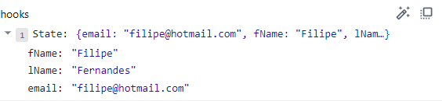
import React, { useState } from "react";

function App() {
const [fullName, setFullName] = useState({
fName: "",
lName: ""
});

function updateName(e) {
const { name, value } = e.target;

setFullName(prevValue => {
return {
...prevValue,
[name]: value
};
});
}

return (
<div className="container">
<h1>
Hello {fullName.fName} {fullName.lName}
</h1>
<form>
<input
name="fName"
onChange={updateName}
placeholder="First Name"
value={fullName.fName}
/>
<input
name="lName"
onChange={updateName}
placeholder="Last Name"
value={fullName.lName}
/>
<button>Submit</button>
</form>
</div>
);
}

Managing a Component Tree

We know from the React Props lesson that a React App will not end up with only one component App. In reality, each component will have its own separated file.

For example, the code below represents a To Do List, with every component in the same App.jsx file. You can add items to this list by typing text in the input field and clicking the Add button.

We have got 2 hooks:
- One to store and update the input text (which will be updated each time the input field is changed)
- One to store and update the list of items (which will be updated each time the Add button is clicked).

The addItem function creates a new array with all the previous items, plus the new item which came from the inputText variable.

App.jsx

import React, { useState } from "react";

function App() {
const [inputText, setInputText] = useState("");
const [items, setItems] = useState([]);

function handleChange(event) {
setInputText(event.target.value);
}

function addItem() {
setItems(prevItems => {
return [...prevItems, inputText];
});
setInputText("");
}

return (
<div className="container">
<div className="heading">
<h1>To-Do List</h1>
</div>
<div className="form">
<input onChange={handleChange} type="text" value={inputText} />
<button onClick={addItem}>
<span>Add</span>
</button>
</div>
<div>
<ul>
{items.map(todoItem => (
<li>{todoItem}</li>
))}
</ul>
</div>
</div>
);
}

export default App;

Result

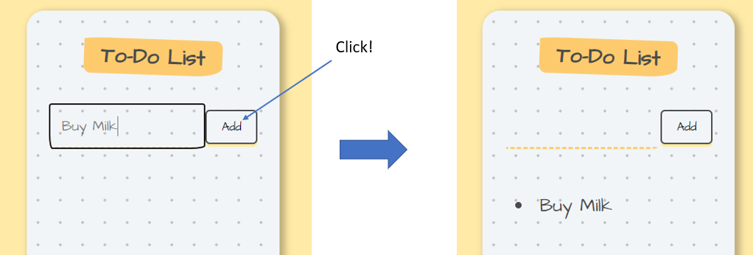

Now, imagine you want to put the list component in a separated file. It would look like this:

import React from "react";

function ToDoItem(props) {

return (
<li>{props.text}</li>
);
}

export default ToDoItem;

The props.text is the text property passed from the in the parent file App.jsx. Also, {todoItem} will now be replaced by the component <ToDoItem/>, as we have learned in the React Props lesson.

<ul>
{items.map((todoItem) => (
<ToDoItem text={todoItem} />
))}
</ul>

And that’s it for stateless components. But now that we have learned about states, we will try to incorporate them into the ToDoItem component. So, imagine we want to be able to add a strike-though line when we click the item.

- We need to create a hook with the initial value of false (in the beginning the item is not clicked):

const [clicked, setClicked] = React.useState(false)

- We need a function that changes the value from false to true and vice-versa. So, it needs to remember the previous value of clicked and change it to the opposite. The function below returns the opposite value of the current clicked variable.

function handleClick() {
setClicked(prevValue => {
return !prevValue
})
}

- We need to apply conditional rendering to the li style and add an Event Handler that calls the function handleClick if the item is clicked.

<li
onClick={handleClick}
style={{textDecoration: clicked ? "line-through" : "none" }}>{props.text}</li>

So, the final code looks like this:

import React from "react";

function ToDoItem(props) {

const [clicked, setClicked] = React.useState(false)

function handleClick() {
setClicked(prevValue => {
return !prevValue
})
}

return (
<li
onClick={handleClick}
style={{textDecoration: clicked ? "line-through" : "none" }}>{props.text}</li>
);
}

export default ToDoItem;

So, we now have a state being managed inside our ToDoItem. But, this state is localized to this item (which works for the line-though goal, which only has to do with the items in the list).

But what if we wanted to delete it from our items array? How do we reach up from our ToDoItem into its parent (App) and somehow change this array? So now, instead of just changing the style of an item, we want to be able to change the entire array.

When we call a component in the App (parent), we cannot only pass variables as props, we can also pass functions:

<ul>
{items.map((todoItem) => (
<ToDoItem
text={todoItem}
onChecked={deleteItem}
/>
))}
</ul>

And then call this function when the event onClick occurs in an item.

import React from "react";

function ToDoItem(props) {

return (
<li
onClick={props.onChecked}>{props.text}</li>
);
}

export default ToDoItem;

But how can we know which item was clicked and delete it from the array?

Remember, when we map through components, we should always have a key, which identifies the object (in this case the item) with a unique id number.

One way to do this is by setting the key value equal to the index that the map function is looping through. Remember the syntax of a map function is

array.map(function(element, index))

in which the index parameter is optional. But, it means we can have access to it and use it to assign key values to each item. So, the ToDoItem component in the App.jsx file will look like this:

<ul>
{items.map((todoItem, index) => (
<ToDoItem
key={index}
id={index}
text={todoItem}
onChecked={deleteItem}
/>
))}
</ul>

And then we need to pass the id property as a prop to the ToDoItem component.

import React from "react";

function ToDoItem(props) {
return <li onClick={props.onChecked(props.id)}>{props.text}</li>;
}

export default ToDoItem;

However, using the syntax above, because onChecked is called with the parenthesis, it means it will be called as soon as the item is rendered, which means it will delete the item as soon as it’s added.

So, we need to find a way of calling the function only when it’s clicked, i.e. without (). So, instead of calling the onChecked function, it will call an anonymous function which will call the onChecked function, and this anonymous function will only be called once the item is clicked.

import React from "react";

function ToDoItem(props) {
return (
<li
onClick={() => {
props.onChecked(props.id);
}}
>
{props.text}
</li>
);
}

export default ToDoItem;

So now we just need to know how to delete an item from the array with the deleteItem function. We can do this using the filter method, which, remember, takes a function as an input which will tell set the condition of the filter. And that function will take the current value that is being filtered, as well as the optional index parameter, which again returns the index of the value being filtered.

array.filter(function(currentValue, index))

So, we need access to store the prevItems array to have access to the last array that was stored. We need to filter through it and find the id (or index) of the item that was clicked.

It will then return all the items of that array which id doesn’t match to the index of the item that was clicked.

function deleteItem(id) {
setItems((prevItems) => {
return prevItems.filter( (item, index) => {
return index !== id
})
})
}

So, the final code will look like this:

App.jsx

import React, { useState } from "react";
import ToDoItem from "./ToDoItem";

function App() {
const [inputText, setInputText] = useState("");
const [items, setItems] = useState([]);

function handleChange(event) {
const newValue = event.target.value;
setInputText(newValue);
}

function addItem() {
setItems(prevItems => {
return [...prevItems, inputText];
});
setInputText("");
}

function deleteItem(id) {
setItems(prevItems => {
return prevItems.filter((item, index) => {
return index !== id;
});
});
}

return (
<div className="container">
<div className="heading">
<h1>To-Do List</h1>
</div>
<div className="form">
<input onChange={handleChange} type="text" value={inputText} />
<button onClick={addItem}>
<span>Add</span>
</button>
</div>
<div>
<ul>
{items.map((todoItem, index) => (
<ToDoItem
key={index}
id={index}
text={todoItem}
onChecked={deleteItem}
/>
))}
</ul>
</div>
</div>
);
}

export default App;

ToDoItem.jsx

import React from "react";

function ToDoItem(props) {
return (
<div
onClick={() => {
props.onChecked(props.id);
}}
>
<li>{props.text}</li>
</div>
);
}

export default ToDoItem;

Converting HTML to React files

- Create a react app.
- Copy and paste the HTML code inside the App component.
- Delete comments or make them JS comments by putting them between {/* comment */}
- Replace all the class for className (use Ctrl + D to help selecting).
- Create a components folder.
- Separate the different elements into components (e.g. Navbar, Hero, Footer, etc).
- Correct the local images source links. Instead of using the path directly in the source, use import.
- Replace repetitive sections of data for iterations. For example, on the HTML, a navbar would look something like this, where the structure repeats itself.

<ul className="nav-links" id="nav-links">
<li><a href="#home" className="nav-link">home</a></li>
<li><a href="#about" className="nav-link">about</a></li>
<li><a href="#services" className="nav-link">services</a></li>
<li><a href="#tours" className="nav-link">tours</a></li>
</ul>

We could create a separate data.js file inside the src folder with the array below. This way, it’s very easy to add new elements to the Navbar component, we just need to add more elements to the pageLinks array

export const pageLinks = [
{ id: 1, href: "#home", text: "home" },
{ id: 2, href: "#about", text: "about" },
{ id: 3, href: "#services", text: "services" },
{ id: 4, href: "#tours", text: "tours" },
];

And on the Navbar component:

<ul className="nav-links" id="nav-links">
{pageLinks.map((link) => {
return (
<li key={link.key}>
<a href={link.href} className="nav-link">
{link.text}
</a>
</li>
);
})}
</ul>

We could of course also use deconstruction to access the properties:
<ul className="nav-links" id="nav-links">
{pageLinks.map((link) => {
const { id, href, text } = link;
return (
<li key={id}>
<a href={href} className="nav-link">
{text}
</a>
</li>
);
})}
</ul>

Creating a React app with Vite

You need Node.js and Hyper installed in order to create a react app with Vite.

- Open the Hyper.
- Change the working directory to the directory you want to create the app in.
- Copy + paste npm create vite@latest my-react-app -- --template react

my-react-app is just the name of your app, so choose whatever you want.

- Open VS.
- Type in the VS terminal npm install to install the dependencies.
- Type in the VS terminal npm run dev

To see the website changes as you code it, click in the link provided in the terminal (ctrl + click):

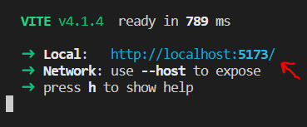

In VITE, all the Javascript files must have the .jsx extension.

To build the application, run the command npm build

